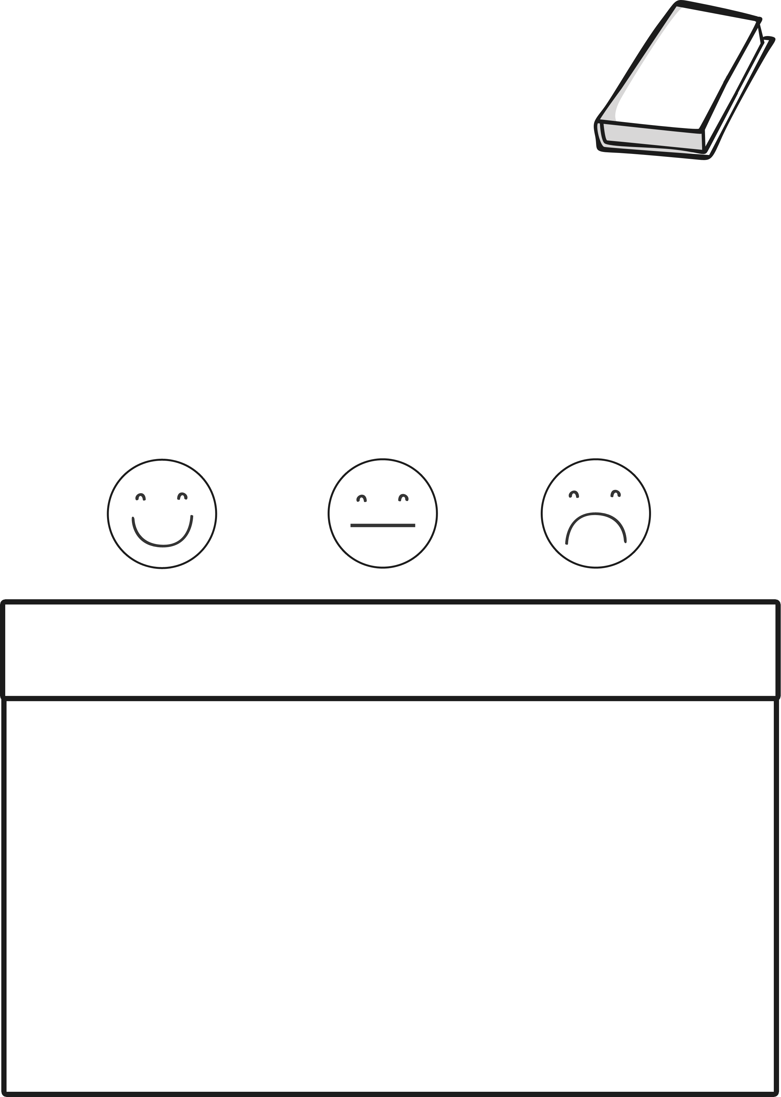
My Book Review
Name: ___________
Date: ____________
Book Title:______________________

How did you feel about this book?
Now draw your favourite part of the book.

