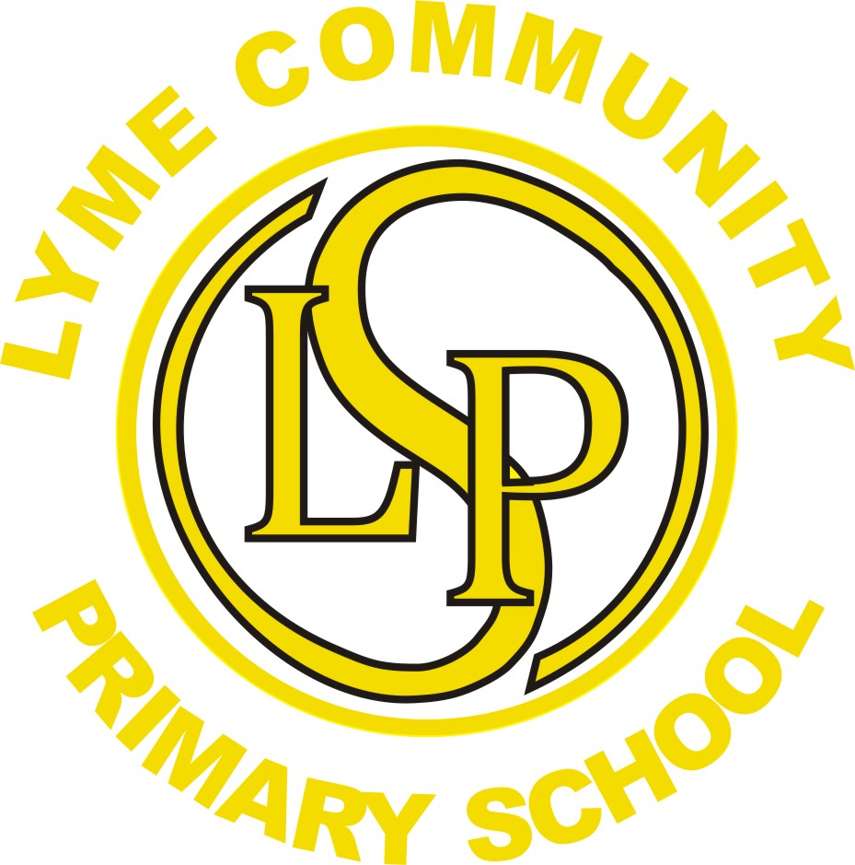
Lyme Community Primary School
I CAN! Inspire Challenge Achieve Nurture

Headteacher: Mrs Marie Cribb
Lyme Street
Newton-le-Willows
Merseyside WA12 9HD
Telephone/Fax 01744 678350
www.lyme.st-helens.sch.uk

Use of Photographs and Responsible Internet Use at Lyme Community Primary School.

Dear Parents/Carers.

As part of your child’s curriculum and the development of IT skills, Lyme Community Primary School provides supervised access to the Internet. We believe that the safe and effective use of IT is an essential skill for children as they grow up in the modern world. Please would you read the attached Rules for Responsible Internet Use and sign and return the consent form so that your child may use Internet at school.

We would like to reassure you that our school Internet provider operates a robust and strict filtering system that restricts access to undesirable or inappropriate materials. However, this may not be the case at home. As responsible Parents/Carers we advise you to take a look at the advice and practical steps given to ensure Family Internet Safety on this website: www.thinkuknow.co.uk/parents/
This site will provide guidance and advice on many of the top parental concerns about the Internet.

Whilst every endeavour is made to ensure that suitable restrictions are placed on the ability of children to access inappropriate materials, the school cannot be held responsible for the nature or content of materials accessed through the Internet. The school will not be liable for any damages arising from your child’s use of the Internet facilities.

Occasionally we may take photographs of the children at school. We use these images as part of our school displays and sometimes in other printed publications like the school newsletter. We will also use some on our school website.

To comply with data protection laws we need parents' permission before we can photograph or make any recording of their children.

Please read the school's policy regarding the use of photographs in school. It can be found on our website or a copy can be provided by request. All parents are required to complete a consent form and completed forms are kept centrally in the school office for reference.

At Lyme Community Primary School we take very seriously our children’s privacy and safety. If parents are given permission to take photos at any school event we would ask that they are kept for personal family use and not published on the Internet.

Should you wish to discuss any aspect of Internet use or if you have any questions or concerns about photograph consent please telephone me to arrange an appointment.

Yours sincerely

Mrs Cribb
Headteacher

Rules for Responsible Internet Use at Lyme

- I will only access the system with my own class login and password.

- I will only use the computers in school for school work or other activities as directed by the Teacher.
- I will not bring in memory sticks from home.
- I will ask permission from a member of staff before using the Internet.
- In school, I will only e-mail people as part of my learning with the permission of my Teacher.
- Amy messages I send will be polite and responsible.
- I will never give my home address or telephone number or arrange to meet anyone.
- I will report any unpleasant material sent to me. I understand my report would be confidential and would protect other pupils and myself.
- I understand that the school or Local Authority check my computer files to monitor the Internet sites I visit.
- I will not copy or use programs that are copyright.
- I will tell my teacher if the computer goes wrong or has a problem.
- I will respect the I.T. resources and will treat them with the care needed to avoid any unnecessary damage.

The school accepts no responsibility for inappropriate use of the Internet outside school, even when children are researching a school based subject.

