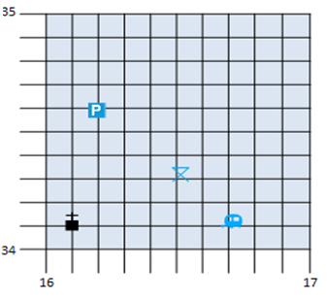

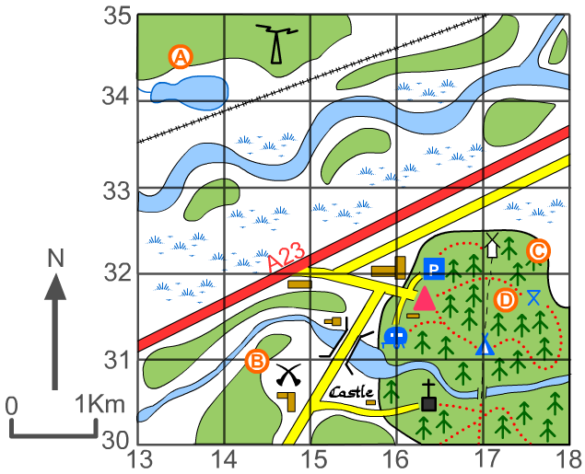
Give the 6 figure grid reference for each of the symbols below.
Give the 6 figure grid references for:
A) __________________
B) ___________________
C) ____________________
D)____________________
Give the 6 figure grid reference for:
The youth hostel (red triangle)____________________
The castle______________________
The church ( ) _______________

