Add the letters in the correct place on the grid below:
57 58 59 60 61 62 63
36

34

33

32

31

30

35

A – 5833
B – 6131
C – 5730
D – 5931
E – 6132

Write the four-figure grid references for the squares labelled below:
57 58 59 60 61 62 63
36

34

33

32

31

30

35

__________
_____________
_____________
_____________
_____________
_____________
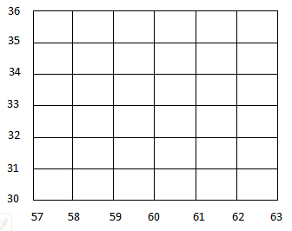
Now create your own

