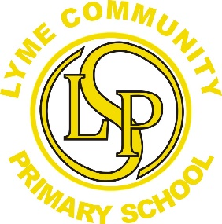
Arts week: Celebrating ‘The Arts’ at Lyme! 

Our theme for our Arts Week is based around each child creating their own sketch books from the artwork undertaken throughout the week.
Our timetable involves all aspects of The Arts including, dance, drama, performance, art and music.
Here is the exciting programme of events…

Tuesday 3rd June
Lyme’s Got Talent launch- inform the children in singing assembly about this event to allow them to develop ideas and rehearse before the auditions.

Monday 23rd June- Audition week
Children to audition in their own classrooms and vote for the acts to go forwards to the Lyme’s Got Talent Show.

Wk Beg. Monday 7th July
All children Nursery to Y6 to create their own ‘sketchbook’ to showcase the artwork created from this week. Themes to vary, linked to the class topics. Samples from each class to be placed on main Art display.

Monday 7th July
LGT dress rehearsal for the whole school (afternoon)

Tuesday 8th July
Final LGT performance for parents. (afternoon)

*Winner and runner up to represent Lyme and enter a St Helens grand final show in September. Details to be confirmed by Business for Youths.

