Lyme CP Progression in Multiplication
Year One | Year Two | Year 3
Understand multiplication is related to doubling and combing groups of the same size (repeated addition)  Washing line, and other practical resources for counting. Concrete objects. Numicon; bundles of straws, bead strings  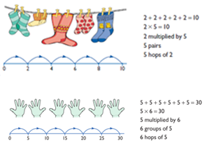  Problem solving with concrete objects (including money and measures  Use cuissenaire and bar method to develop the vocabulary relating to ‘times’ –  Pick up five, 4 times  Use arrays to understand multiplication can be done in any order (commutative) 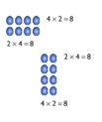 | Expressing multiplication as a number sentence using x  Using understanding of the inverse and practical resources to solve missing number problems.  7 x 2 = = 2 x 7  7 x = 14 14 = x 7  x 2 = 14 14 = 2 x  x ⃝ = 14 14 = x ⃝  Develop understanding of multiplication using array and numberlines. Include multiplications not in the 2, 5 or 10 times tables.  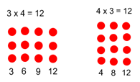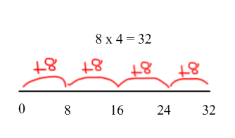  Begin to develop understanding of multiplication as scaling (3 times bigger/taller)  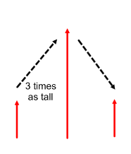  Doubling numbers up to 10 + 10  Link with understanding scaling  Using known doubles to work out  double 2 digit numbers  (double 15 = double 10 + double 5)  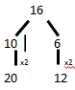  Use jottings and manipulatives to develop an understanding of doubling two digit numbers  2, 3, 5, 10 - Use of number square to reinforce recognising patterns E.g.  2 even. 5 ends in 0 or 5 10 ends in 0 | Missing number problems  Continue with a range of equations as in Year 2 but with appropriate numbers.  Mental methods  Doubling 2 digit numbers using partitioning  Demonstrating multiplication on a number line – jumping in larger groups of amounts  13 x 4 = 10 groups 4 = 3 groups of 4  Written methods (progressing to 2d x 1d)  Developing written methods using understanding of visual images  Develop onto the grid method  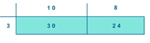  Give children opportunities for children to explore this and deepen understanding using Dienes apparatus and place value counters.  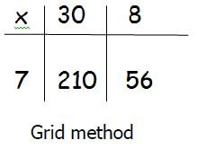  Extend to abstract.  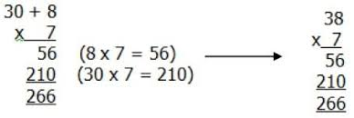  2, 3, 4, 5, 6, 8, 9, 10

Year Four | Year Five | Year 6
Continue with a range of equations as in Year 2 but with appropriate numbers. Also include equations with missing digits  2 x 5 = 160  Mental methods  Counting in multiples of 6, 7, 9, 25 and 1000, and steps of 1/100.  Solving practical problems where children need to scale up. Relate to known number facts. (e.g. how tall would a 25cm sunflower be if it grew 6 times taller?)  Written methods (progressing to 3d x 2d)  Children to embed and deepen their understanding of the grid method to multiply up 2d x 2d. Ensure this is still linked back to their understanding of arrays and place value counters.  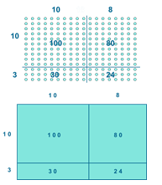 | Continue with a range of equations as in Year 2 but with appropriate numbers. Also include equations with missing digits  Mental methods  X by 10, 100, 1000 using moving digits ITP  Use practical resources and jottings to explore equivalent statements (e.g. 4 x 35 = 2 x 2 x 35)  Recall of prime numbers up 19 and identify prime numbers up to 100 (with reasoning)  Solving practical problems where children need to scale up. Relate to known number facts.  Identify factor pairs for numbers  Written methods (progressing to 4d x 2d)  Long multiplication using place value counters  Children to explore how the grid method supports an understanding of long multiplication (for 2d x 2d)  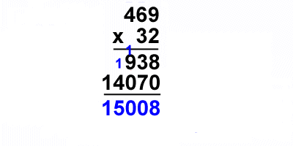 | Continue with a range of equations as in Year 2 but with appropriate numbers. Also include equations with missing digits  Mental methods  Identifying common factors and multiples of given numbers  Solving practical problems where children need to scale up. Relate to known number facts.  Written methods  Continue to refine and deepen understanding of written methods including fluency for using long multiplication  