222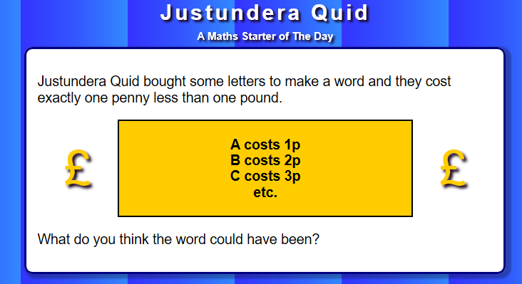
A | B | C | D | E | F | G | H | I | J
1 | 2 | 3 | 4 | 5 | 6 | 7 | 8 | 9 | 10

K | L | M | N | O | P | Q | R | S | T
11 | 12 | 13 | 14 | 15 | 16 | 17 | 18 | 19 | 20

A | B | C | D | E | F
1 | 2 | 3 | 4 | 5 | 6

