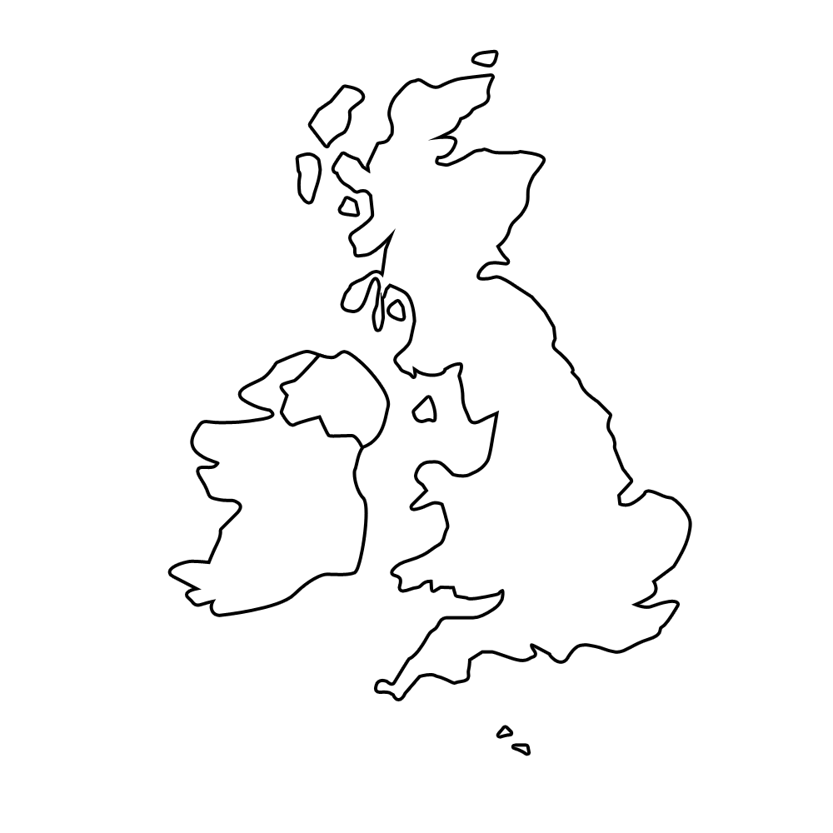

Can you mark **St. Helens** on your map?

Can you mark the cities of **London, Edinburgh, Cardiff, Belfast,** **Dublin, Manchester and Liverpool** on your map?

Where have you visited/been on holiday?

Can you mark these locations on your map?

Can you split the British Isles into **England, Scotland, Wales, Northern Ireland** and **the Republic of Ireland**?