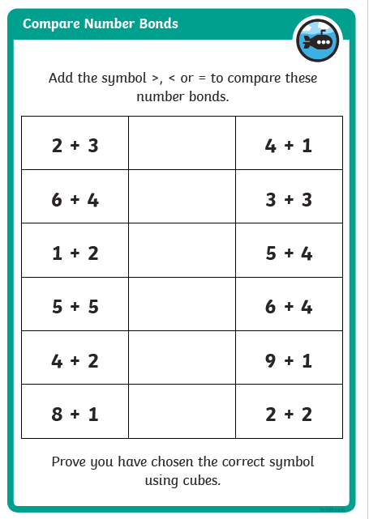< means less than
> means greater / bigger than
= equal

