Sort the animals into the groups below. You could either cut them out and place them into groups or enter the animal names into the table.
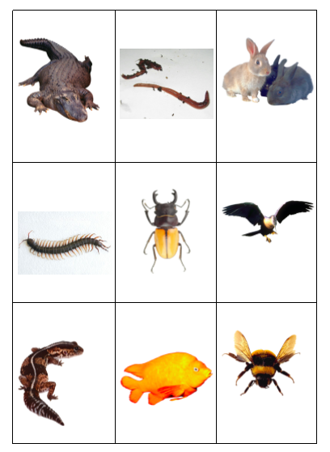

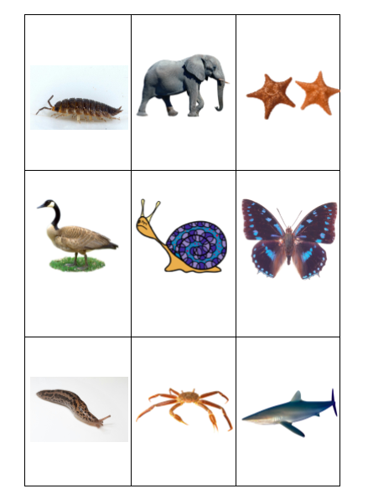

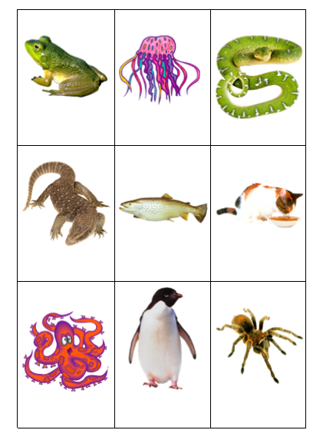

Extension task:​ Can you find more animals to add to the groups?

