Animal Fact File

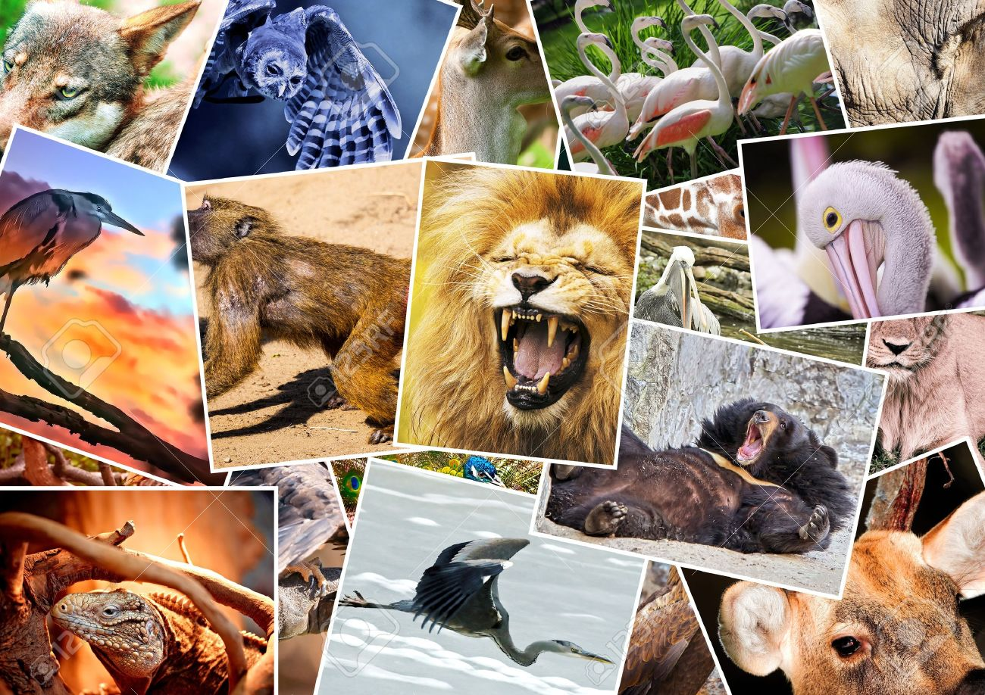

Written by Henry Pollard
Wolves

Wolves look like dogs. They have sharp teeth and sharp claws.

Wolves live in many habitats like the forest.

Wolves eat bison.

Baby wolves are called pups.

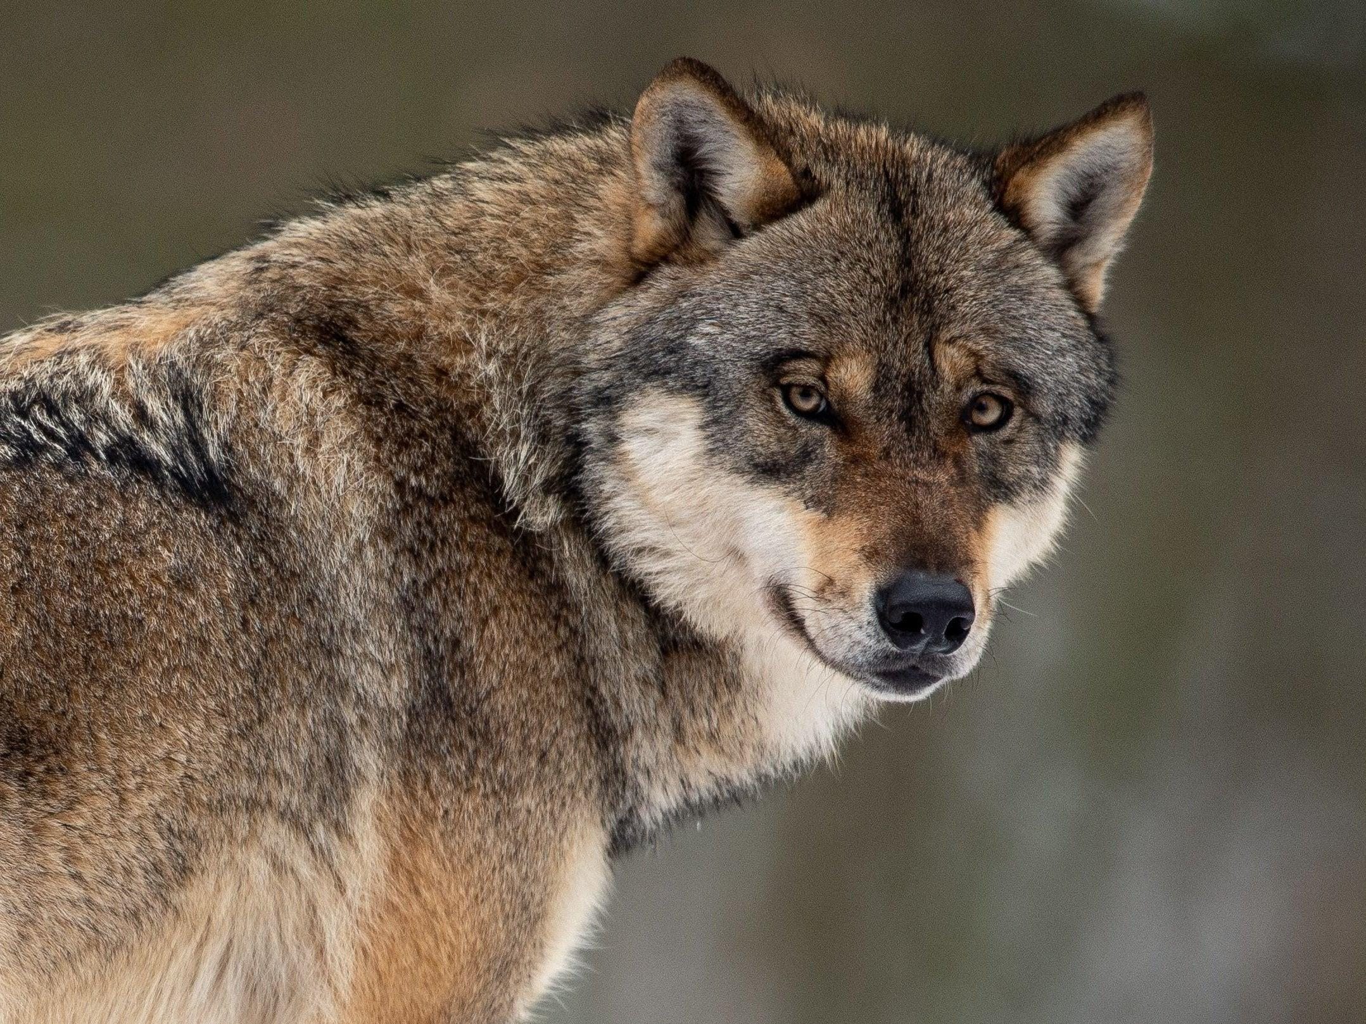
Clown Fish

Clown fish have orange and white stripes.

Clown fish live in the ocean.

Clown fish eat algae and worms.

Baby fish are called fry.

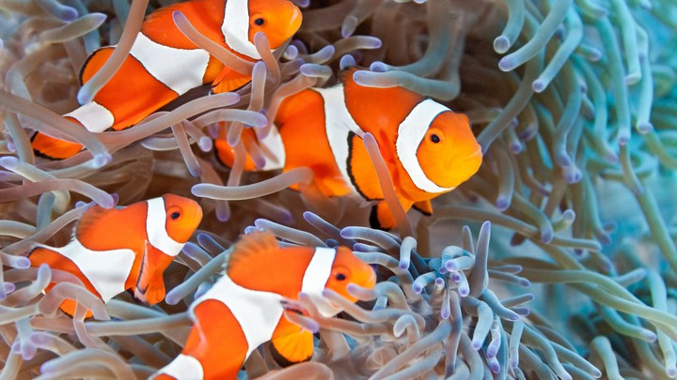
Polar Bears

Polar bears are very big. They have white fur.

Polar bears live in the Arctic.

They are carnivores. They eat seals and whales.

Baby polar bears are cubs.

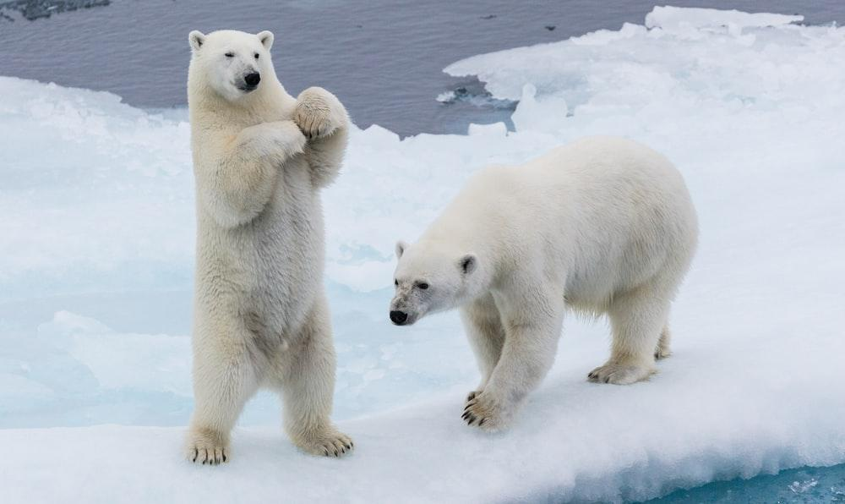
Animal Fact File

This is a non-fiction book about animals in different habitats.

