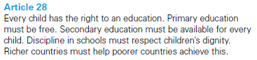
Lyme CP Progression in Division
Year One | Year Two | Year Three
Children must have secure counting skills- being able to confidently count in 2s, 5s and 10s.  Children should be given opportunities to reason about what they notice in number patterns.  Group AND share small quantities- understanding the difference between the two concepts.  Sharing  Develops importance of one-to-one correspondence.  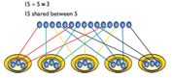  Children should be taught to share using concrete apparatus.  Grouping  Children should apply their counting skills to develop some understanding of grouping. 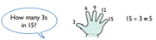  Use of arrays as a pictorial representation for division. 15 ÷ 3 = 5 There are 5 groups of 3.  15 ÷ 5 = 3 There are 3 groups of 5.  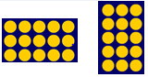  Children should be able to find ½ and ¼ and simple fractions of objects, numbers and quantities. | ÷ = signs and missing numbers  6 ÷ 2 = = 6 ÷ 2  6 ÷ = 3 3 = 6 ÷  ÷ 2 = 3 3 = ÷ 2  ÷ ∇ = 3 3 = ÷ ∇  Know and understand sharing and grouping- introducing children to the ÷ sign.  Children should continue to use grouping and sharing for division using practical apparatus, arrays and pictorial representations.  Grouping using a numberline  Group from zero in jumps of the divisor to find our ‘how many groups of 3 are there in 15?’.  15 ÷ 3 = 5  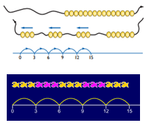  Continue work on arrays. Support children to understand how multiplication and division are inverse. Look at an array – what do you see?  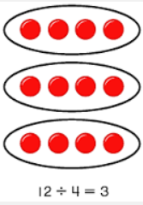  Counting in multiples – looking for patterns.  3, 6, 9, 12, 15, 18, 21, 24 | ÷ = signs and missing numbers  Continue using a range of equations as in year 2 but with appropriate numbers.  Grouping  How many 6’s are in 30?  30 ÷ 6 can be modelled as: 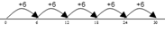  Becoming more efficient using a numberline  Children need to be able to partition the dividend in different ways.  48 ÷ 4 = 12  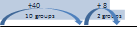  Remainders  49 ÷ 4 = 12 r1  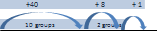  Sharing – 49 shared between 4. How many left over?  Grouping – How many 4s make 49. How many are left over?  Place value counters can be used to support children apply their knowledge of grouping.  For example:  60 ÷ 10 = How many groups of 10 in 60?  600 ÷ 100 = How many groups of 100 in 600? 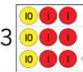

Year Four | Year Five | Year Six
÷ = signs and missing numbers  Continue using a range of equations as in year 3 but with appropriate numbers.  Sharing, Grouping and using a number line  Children will continue to explore division as sharing and grouping, and to represent calculations on a number line until they have a secure understanding. Children should progress in their use of written division calculations:  - Using tables facts with which they are fluent  - Experiencing a logical progression in the numbers they use, for example:  - Dividend just over 10x the divisor, e.g. 84 ÷ 7  - Dividend just over 10x the divisor when the divisor is a teen number, e.g. 173 ÷ 15  - Dividend over 100x the divisor, e.g. 840 ÷ 7  - Dividend over 20x the divisor, e.g. 168 ÷ 7  Children begin by writing a partial table including doubling, ten lots and 5 lots.  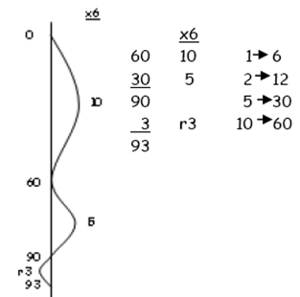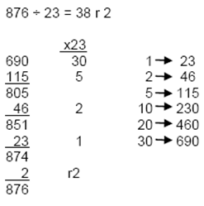  All of the above stages should include calculations with remainders as well as without. |  | ÷ = signs and missing numbers  Continue using a range of equations but with appropriate numbers  Sharing and Grouping and using a number line  Children will continue to explore division as sharing and grouping, and to represent calculations on a number line as appropriate.  Quotients should be expressed as decimals and fractions  Formal Written Methods – long and short division  E.g. 1504 ÷ 8  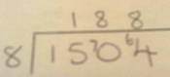  E.g. 2364 ÷ 15  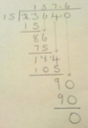
Formal Written Methods  Formal short division should only be introduced once children have a good understanding of division, its links with multiplication and the idea of ‘chunking up’ to find a target number (see use of number lines above)  Short division to be modelled for understanding using place value counters as shown below. Calculations with 2 and 3-digit dividends. E.g. fig 1  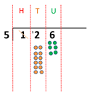 | Formal Written Methods  Continued as shown in Year 4, leading to the efficient use of a formal method. The language of grouping to be used (see link from fig. 1 in Year 4) E.g. 1435 ÷ 6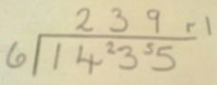  Children begin to practically develop their understanding of how to express the remainder as a decimal or a fraction. Ensure practical understanding allows children to work through this

